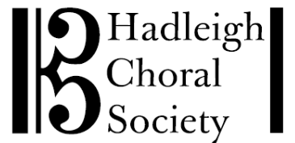
helenrogerson@gmail.com

Rt Hon James Cartlidge MP 21st May 2021
House of Commons
London
SW1A OAA

Dear Mr Cartlidge

I am writing on behalf of Hadleigh Choral Society, an amateur choir of some 100 members, to ask why new restrictions have this week been placed on our meeting indoors for rehearsals.

In Autumn 2020, we ran a very successful and much appreciated series of rehearsals for 45 of our members in our covid-compliant rehearsal hall. The rehearsals were held in 2 sessions each evening, with social distancing, track and trace, hand sanitisers, the wearing of face masks and the hall suitably ventilated. A full risk assessment was put together and distributed to all members, along with comprehensive instructions on how the rehearsals would be run in order to keep everyone safe.

As you will be aware, singing together in a group has huge benefits for people’s physical and mental well-being. We would also question why singing appears to be singled out for the rule of six, when organised indoor sport is permissible, with no limit on numbers other than the capacity restrictions of the venue.

The timing of the decision was also frustrating, coming just as the easing of restrictions came into play on 17th May. There was no warning to choirs, or it appears their representative organisations, in our case Making Music, which posted the new guidelines on Tuesday afternoon, just hours before our first rehearsal which we obviously duly cancelled.

We would very much appreciate your support in this matter and your representation of our views to the Department of Culture, Music & Sport. We very much hope the Minister will re-consider his decision.

Yours sincerely

Helen Rogerson
Secretary

